УО «Белорусский государственный университет информатики и радиоэлектроники»

Кафедра ПОИТ

Отчет по лабораторной работе №1.1

по предмету «Основы алгоритмизации и программирования»

Вариант 16

Выполнил:

Кужик Д. С.

Гр. 451003

Проверил:

Данилова Г. В.

Минск 2024

**Задание:**

Даны координаты точки М(х,у). Определить, принадлежит ли данная точка замкнутому множеству D, заданному системой ограничений:

$\left\{\begin{aligned}x+y≤1 \\ 2x-y≤1 \\ y≥0\end{aligned}\right.$

**Код программы Delphi:**

**Program Lab1;**

**Uses**

**System.SysUtils;**

**Const**

**INPUT_ACCURACY :Integer = 20;**

**INACCURACY :Real = 0.0000001;**

**Var**

**IsWork:Boolean;**

**X, Y:Real;**

**Begin**

**X := 0.0;**

**Y := 0.0;**

**WriteLn('This program determines, whether a point (x,y) belongs to the closed set D');**

**Repeat**

**IsWork := True;**

**WriteLn('Please enter the x coordinate within +/- ', INPUT_ACCURACY);**

**Try**

**ReadLn(X);**

**Except**

**IsWork := False;**

**End;**

**If IsWork And ((X < -INPUT_ACCURACY) Or (X > INPUT_ACCURACY)) Then**

**Begin**

**WriteLn('The number is out of range.');**

**IsWork := False;**

**End;**

**Until IsWork;**

**Repeat**

**IsWork := True;**

**WriteLn('Please enter the y coordinate within +/- ', INPUT_ACCURACY);**

**Try**

**ReadLn(Y);**

**Except**

**IsWork := False;**

**End;**

**If IsWork And ((Y < -INPUT_ACCURACY) Or (Y > INPUT_ACCURACY)) Then**

**Begin**

**WriteLn('The number is out of range.');**

**IsWork := False;**

**End;**

**Until IsWork;**

**If ((X + Y < 1.0 + INACCURACY) And (2.0 * X - Y < 1.0 + INACCURACY) And (Y + INACCURACY > 0.0)) Then**

**WriteLn ('This point belongs to a closed set D')**

**Else**

**WriteLn ('This point doesn''t belong to a closed set D');**

**End.**

**Код программы С++:**

**#include <iostream>**

**const int INPUT_ACCURACY = 20;**

**const float INACCUARCY = 0.0000001;**

**int main() {**

**bool isNotWork;**

**double x, y;**

**x = 0.0;**

**y = 0.0;**

**std::cout << "This program determines, whether a point (x,y) belongs to the closed set D\n";**

**isNotWork = true;**

**std::cout << "Please enter the x coordinate within +/- " << INPUT_ACCURACY << "\n";**

**do {**

**std::cin >> x;**

**if (std::cin.fail()){ //Ввели не число**

**std::cin.clear();**

**while (std::cin.get() != '\n');**

**std::cout << "Please enter a number again\n";**

**}**

**else if (std::cin.peek() != '\n') { //Ввели число и мусор**

**while (std::cin.get() != '\n');**

**std::cout << "Please enter ONLY a number again\n";**

**}**

**else if (x > INPUT_ACCURACY || x < -INPUT_ACCURACY) { //Ввели число вне диапазона**

**std::cout << "Please enter a number again within +/- " << INPUT_ACCURACY << "\n";**

**}**

**else**

**isNotWork = false;**

**} while (isNotWork);**

**isNotWork = true;**

**std::cout << "Please enter the y coordinate within +/- " << INPUT_ACCURACY << "\n";**

**do {**

**std::cin >> y;**

**if (std::cin.fail()){ //Ввели не число**

**std::cin.clear();**

**while (std::cin.get() != '\n');**

**std::cout << "Please enter a number again\n";**

**}**

**else if (std::cin.peek() != '\n') { //Ввели число и мусор**

**while (std::cin.get() != '\n');**

**std::cout << "Please enter ONLY a number again\n";**

**}**

**else if (y > INPUT_ACCURACY || y < -INPUT_ACCURACY) { //Ввели число вне диапазона**

**std::cout << "Please enter a number again within +/- " << INPUT_ACCURACY << "\n";**

**}**

**else**

**isNotWork = false;**

**} while (isNotWork);**

**if ((x + y < 1.0 + INACCUARCY) && (2.0 * x - y < 1.0 + INACCUARCY) && (y + INACCUARCY > 0.0))**

**std::cout << "This point belongs to the closed set D.\n";**

**else**

**std::cout << "This point doesn't belong to the closed set D.\n";**

**return 0;**

**}**

**Код программы Java:**

**import java.util.Scanner;**

**public class Main {**

**static final int INPUT_ACCURACY = 20;**

**static final double INACCUARCY = 0.0000001;**

**public static void main(String[] args) {**

**Scanner scan = new Scanner(System.in); //ввод**

**boolean isWork;**

**double x, y;**

**x = 0;**

**y = 0;**

**System.out.println("This program determines, whether a point (x,y) belongs to the closed set D.");**

**System.out.println("Please enter the x coordinate within +/-" + INPUT_ACCURACY);**

**do {**

**isWork = false;**

**try {**

**x = Double.parseDouble(scan.nextLine());**

**} catch (NumberFormatException exception) {**

**System.out.println("Please enter ONLY a number again");**

**isWork = true;**

**}**

**if (!isWork)**

**if (x < INPUT_ACCURACY && x > -INPUT_ACCURACY) {**

**isWork = false;**

**}**

**else {**

**System.out.println("Please enter a number again within +/-" + INPUT_ACCURACY);**

**isWork = true;**

**}**

**} while (isWork);**

**System.out.println("Please enter the y coordinate within +/-" + INPUT_ACCURACY);**

**do {**

**isWork = false;**

**try {**

**y = Double.parseDouble(scan.nextLine());**

**} catch (NumberFormatException exception) {**

**System.out.println("Please enter ONLY a number again");**

**isWork = true;**

**}**

**if (!isWork)**

**if (y < INPUT_ACCURACY && y > -INPUT_ACCURACY) {**

**isWork = false;**

**}**

**else {**

**System.out.println("Please enter a number again within +/-" + INPUT_ACCURACY);**

**isWork = true;**

**}**

**} while (isWork);**

**if ((x + y < 1.0 + INACCUARCY) && (2.0 * x - y < 1.0 + INACCUARCY) && (y + INACCUARCY > 0.0))**

**System.out.println("This point belongs to the closed set D.");**

**else**

**System.out.println("This point doesn't belong to the closed set D.");**

**scan.close();**

**}**

**}**

**Скриншоты:**

**Delphi:**

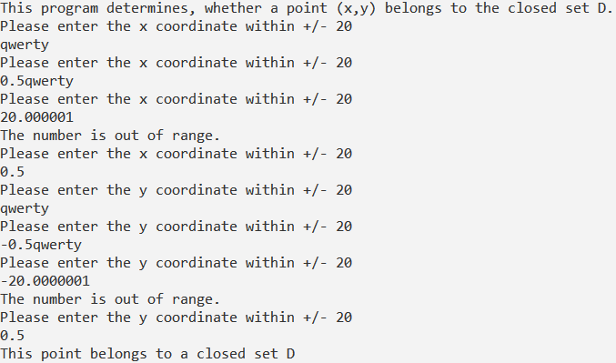

**C++:**

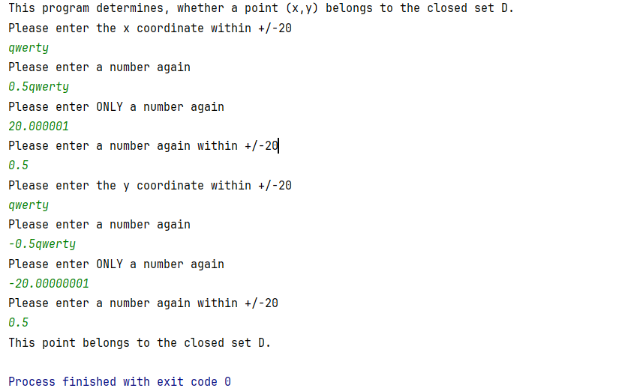

**Java:**

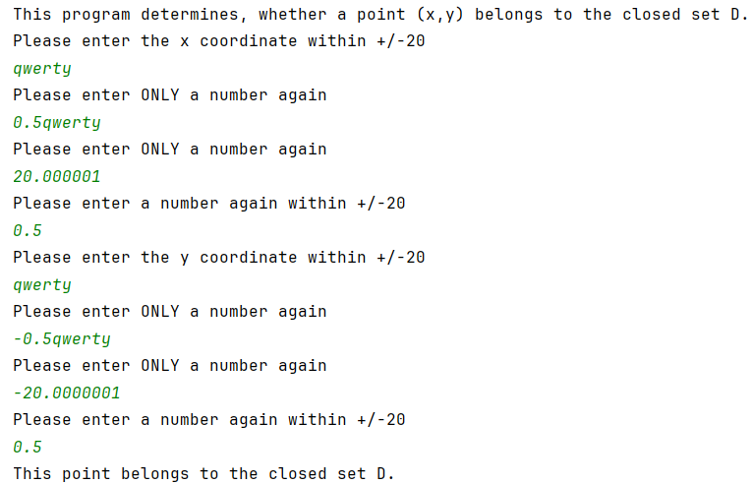

**Блок-схема**